**WAGNER—**Letter F – 6/4 meter

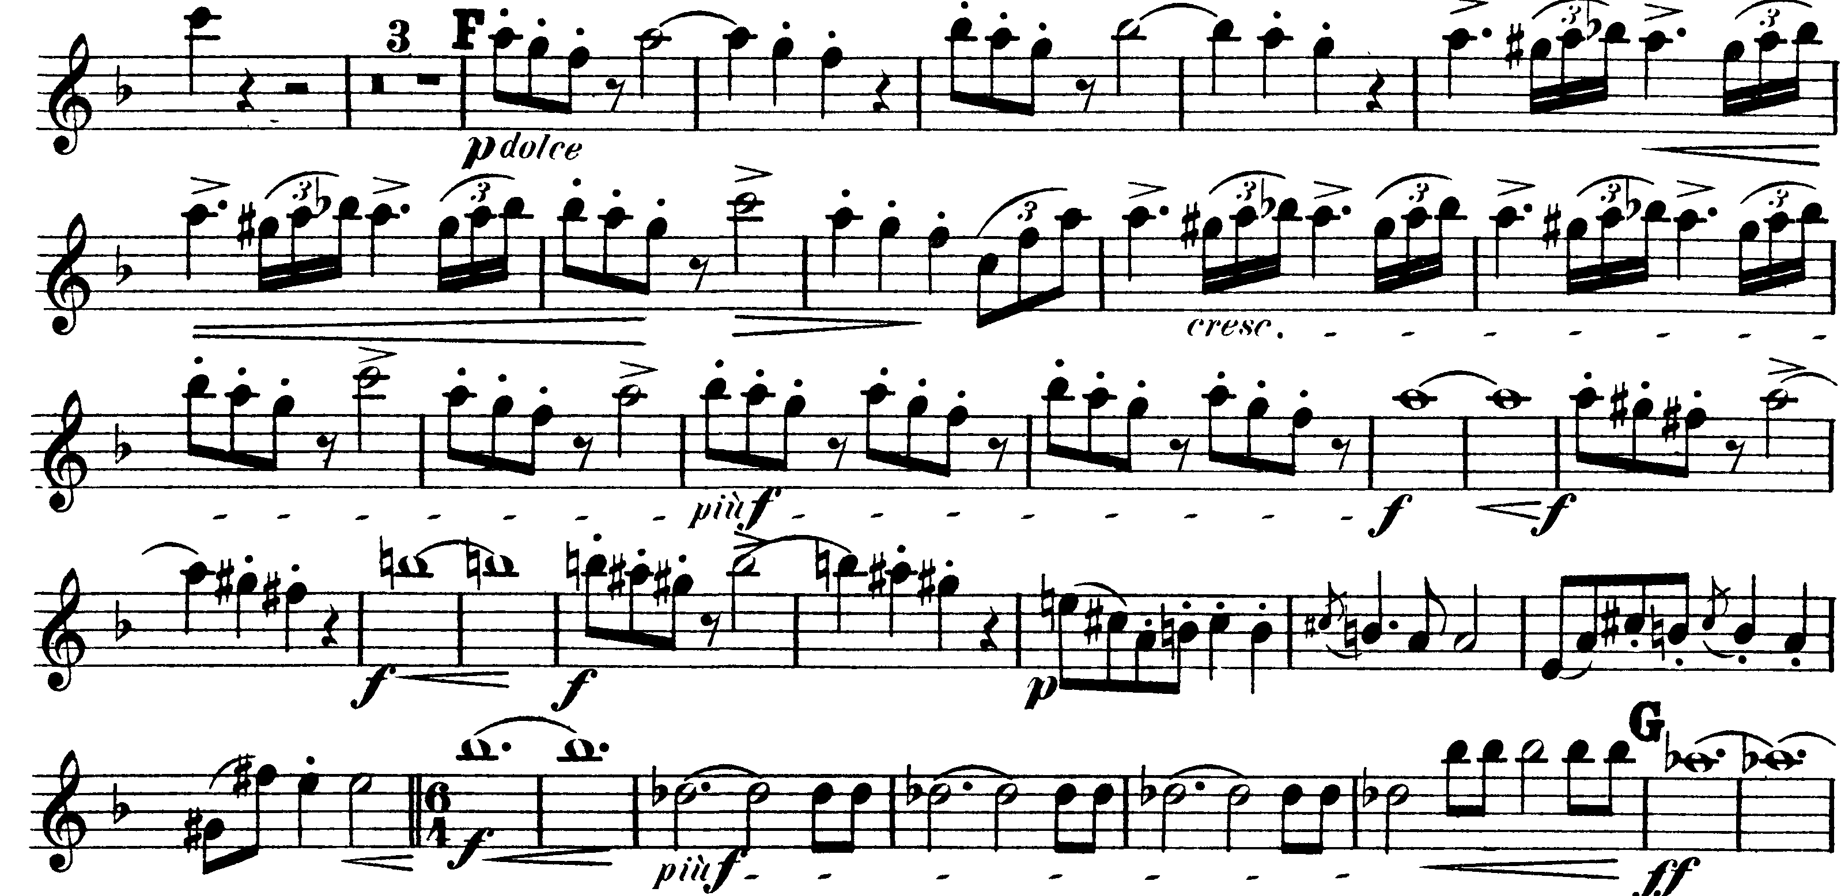

Letter L – *piano* before 1 measure rest

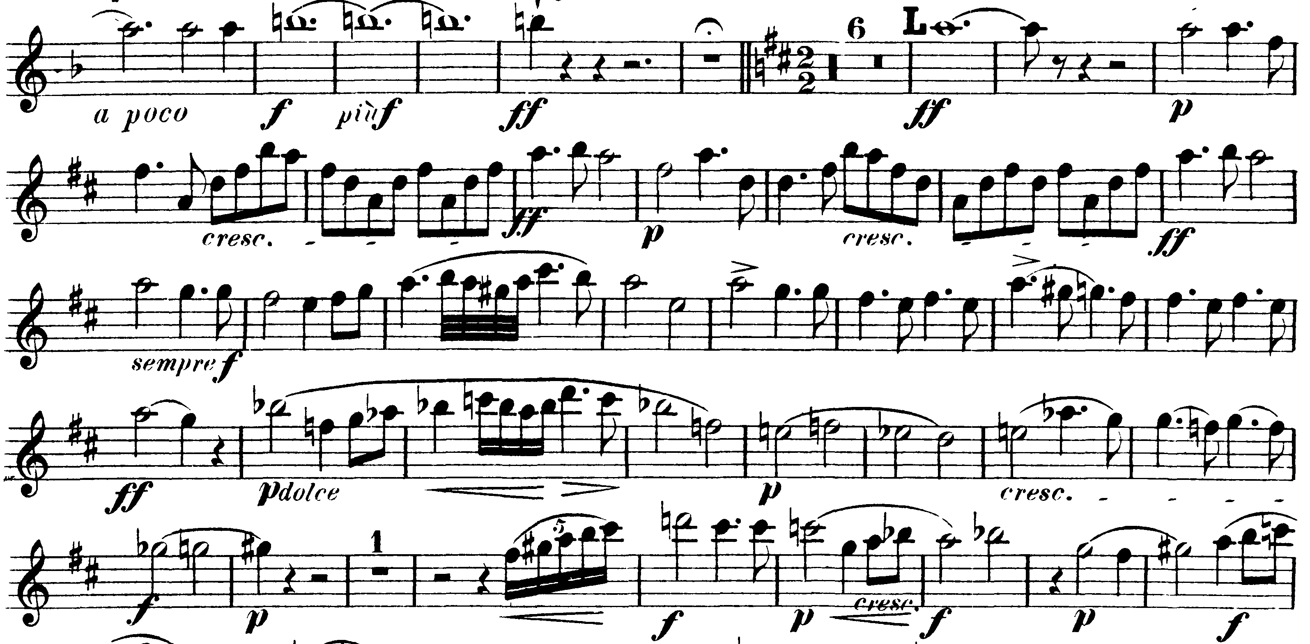

**TCHAIKOVSKY—**Mvt I: M – 276

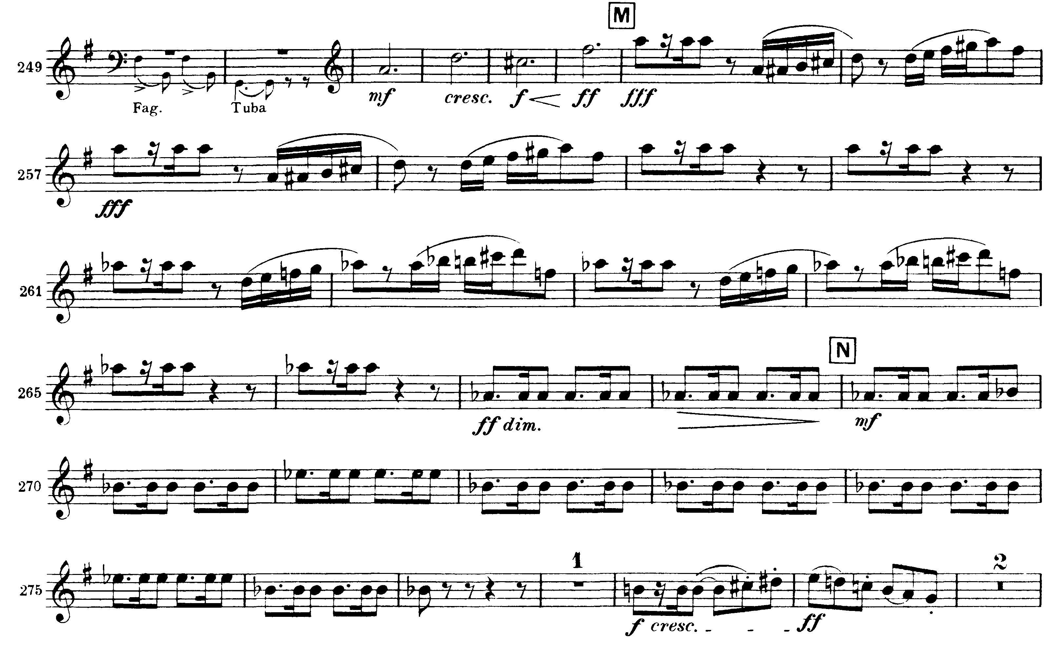

Mvt III: M – 197

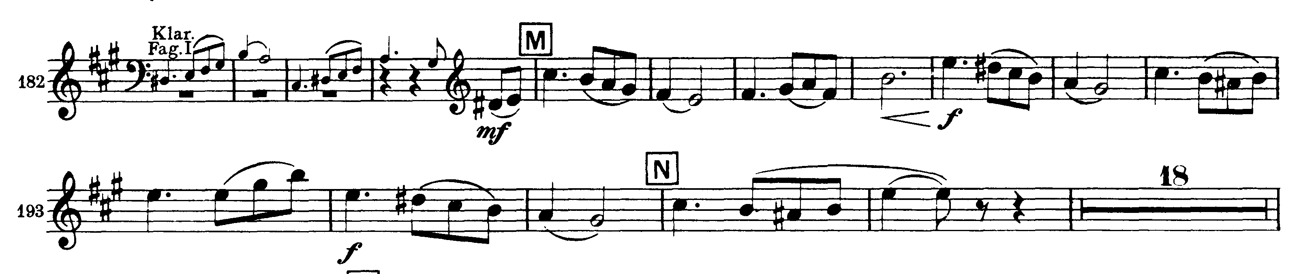

Mvt IV: Presto – Dd

